Portland State University
Water Treatment Procedure
Standard Work Practice
February 2018

Facilities and Property Management – System Services
Job :  Water Treatment Procedure |  | Department/Unit:  System Services
Hazards:
- Material Handling/lifting
- Chemical Exposure
- Chemical Spill

Personal Protective Equipment:  - Face Shield  - Chemical Gloves  - Chemical Apron  - Shoes/Boots with good traction |  | Recommended:  - PPE stations at each water treatment location with the required PPE.  - Verify that there are Eye Wash Station at each water treatment location.
Other requirements to perform the task safely:  - SDS/Hazard Communication  - Access to SDS for Chemicals used in procedure.  - Sealable 5 gallon containers.  - Carts/dollies to transport 5 gallon containers. |  | Hazard Communication Training required on the following SDS:  - NALCO: 3D Trasar 3DT247  - NALCO: Stabrex ST70  - NALCO: S0940-3D Trasar  - Science Lab: Propylene Glycol  - Watercare Industrial: 2500
Steps to be taken to complete task safely
If the worker believes that they cannot complete the task by following the SWP, or that there may be other hazards that the SWP does not address, they must stop work and report to their immediate supervisor.
1 | Nalco Water, a division of Ecolab, delivers and secures chemicals to SRTC sub-basement. These chemicals are in closed 55 gallon barrels and are secured upon delivery by the Nalco representative. |  | 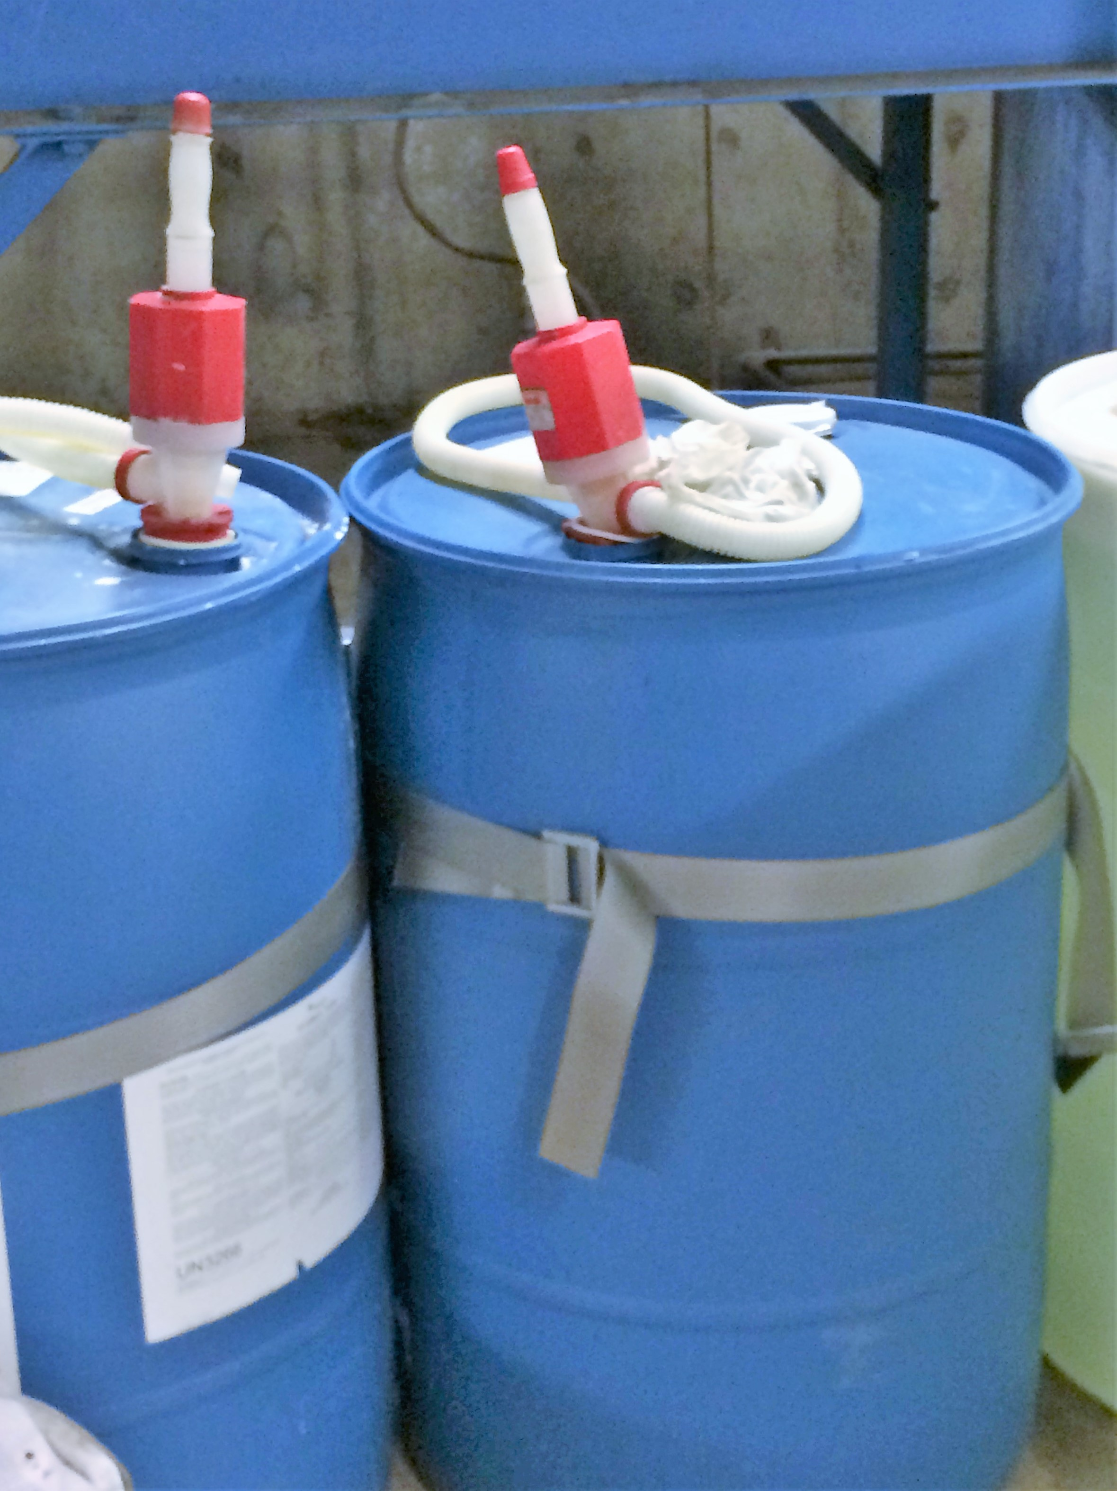
2 | A hand powered pump is set-up on the individual barrels by the Nalco Water representative at the time they are delivered. The barrel remains sealed after the pump is installed. |  | 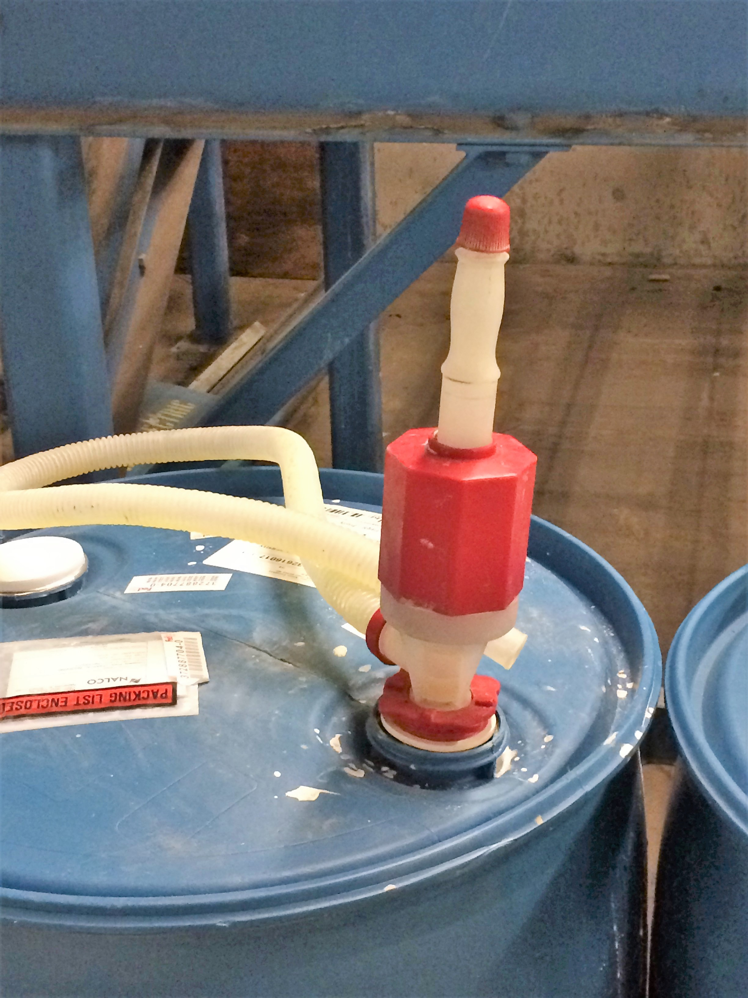
3 | A SDS is attached to each barrel at the time of delivery. This assures access to the SDS at the point of use. Also SDS kept on file in the System Services Office. |  | 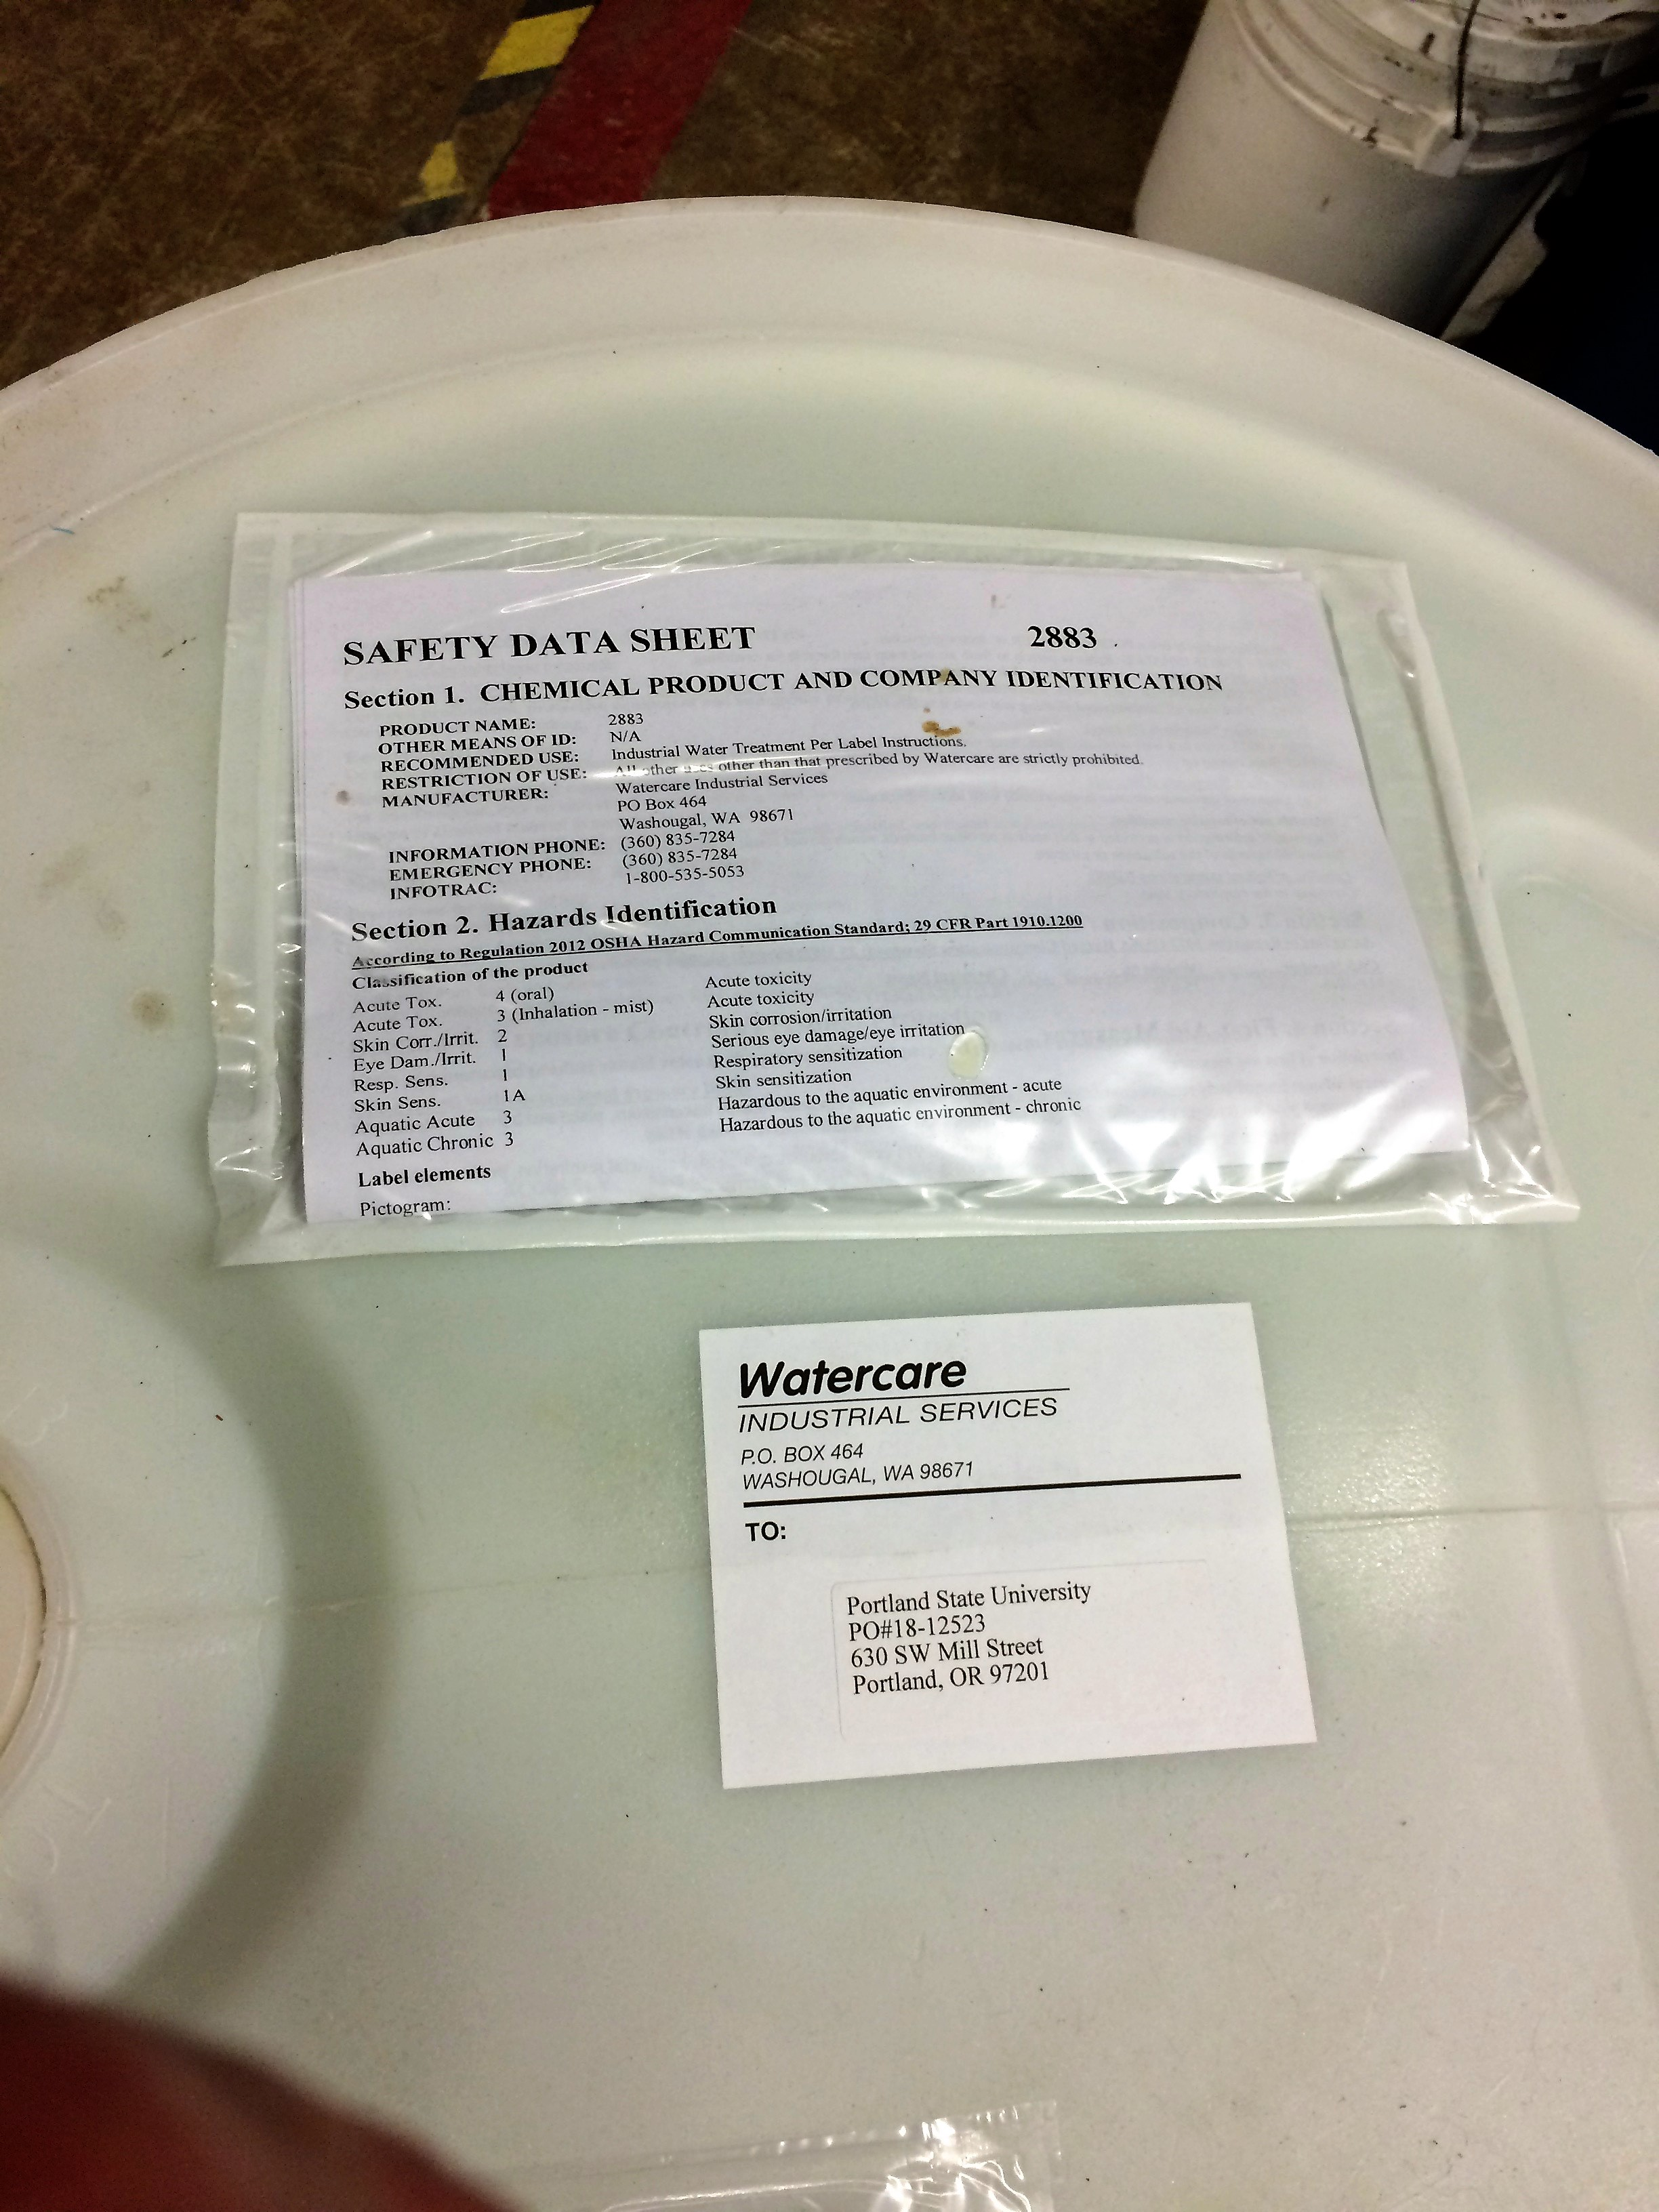
4 | Personal Protective Equipment is kept at each station and must be worn at all times when handling chemicals. This includes:  - Face Shield  - Chemical Gloves  - Chemical Apron |  | 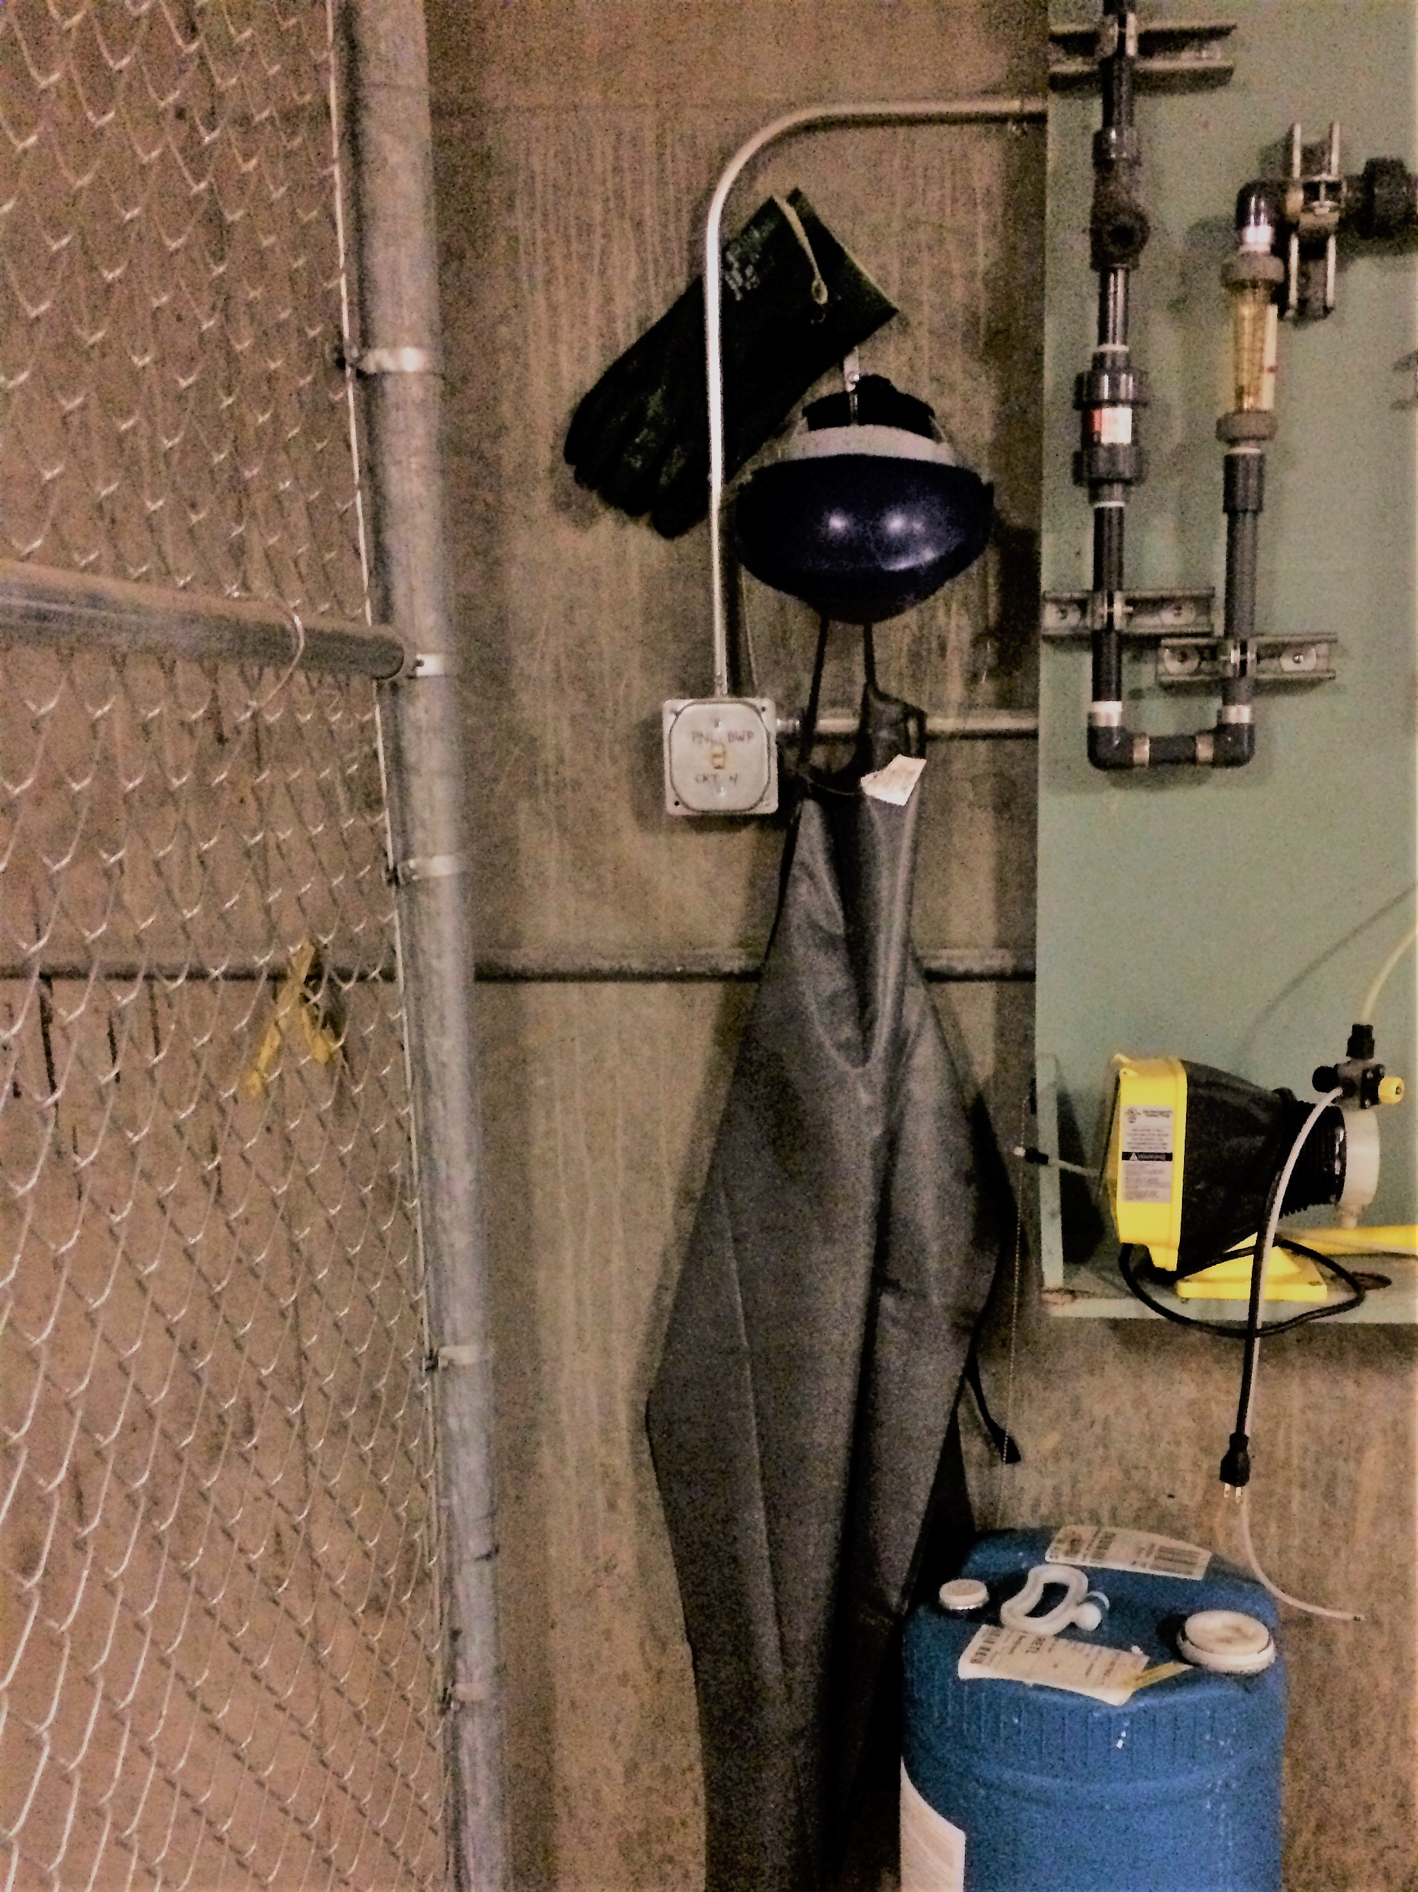
5 | Using hand pump, transfer chemical to properly labeled sub-container. Sub-containers are never to be filled more than half-way.  Once filled seal the sub-container prior to moving or loading on cart/hand truck. |  | 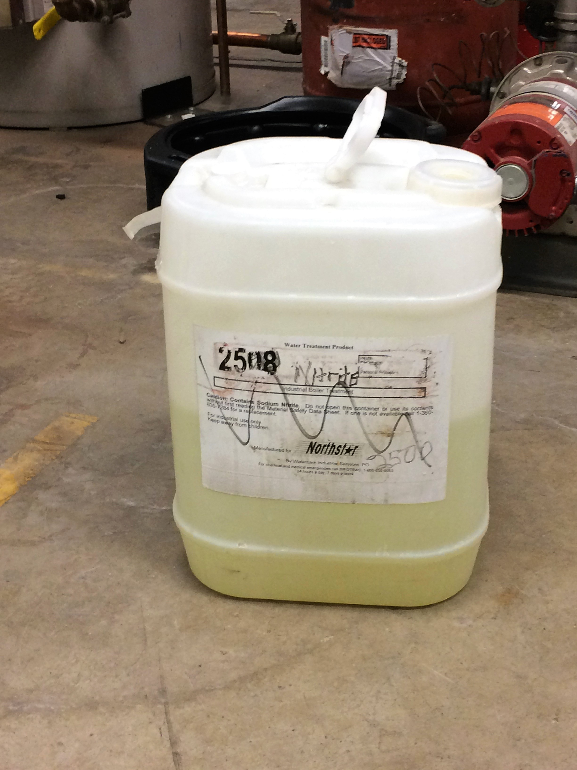
6 | Place sub-container on cart or dolly and secure. Once secured and ready for transport PPE can be taken off.
7 | Upon arrival at water treatment station put on PPE prior to taking sub-container off cart/hand truck.
8 | Place sub-container at pump station and then remove seal and place pumping tube into sub-container. |  | 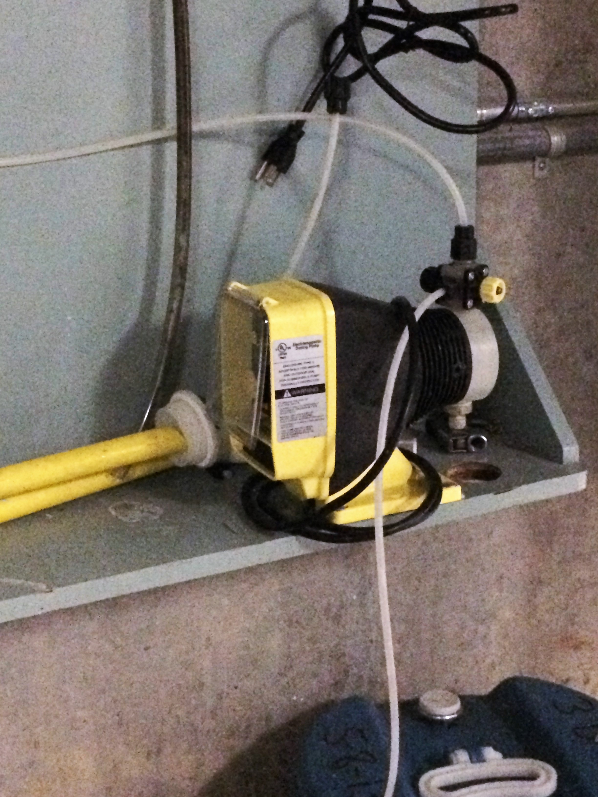
 | Note: This task will be monitored periodically to ensure compliance and effectiveness.

