Reducing the Trauma of Investigation, Removal and Out-of-Home Placement in Child Abuse Cases



Time: 3 hrs

Participants: 25 - 100

Reducing the Trauma of Investigation, Removal and Out-of-Home Placement in Child Abuse Cases

Learning Outcome:
In your capacity as first responders you will enhance your ability to:

- Respond intentionally and purposefully with trauma informed strategies

- Collaborate across disciplines and roles with other first responders

- Reduce trauma and retraumatization for children during investigation, removal and out-of-home placement in child abuse cases

Audience:
First responders at investigation, removal and out-of-home placement in child abuse cases including but not limited to law enforcement, child welfare, foster parents, medical personnel, educators or parents.

Materials:
- Lisa 911 call. Download audio file free-of-charge from http://nctsn.org/nccts/nav.do?pid=ctr_cwtool Click on LISA 9-1-1 Call (Audio File)
- Katie’s Stories of Removal - Electronically Embedded in Power Point Slide #17. Contact Angela Rodgers at rodgersa@pdx.edu, or 503-725-8022 to have an electronic copy with the video sent to you.
- Post-It™ Notes
- Fine tipped colored markers such as Sharpies™
- Easel pads with stands-1 for every 25 participants

Handouts:
- The Impact of Trauma on Child Development and Functioning
- Safe Sensory Tools
- Assignment Sheet for Study Team A-copy for 1/3 of participants
- Assignment Sheet for Study Team B-copy for 1/3 of participants
- Assignment Sheet for Study Team C-copy for 1/3 of participants
- The Impact of Trauma on Children at Different Ages
- What is the Potential Trauma to Children during Investigation?
- What is the Potential Trauma to Children during Removal?
- What is the Potential Trauma to Children during Initial Out-of-Home Placement?
- T.I.P.S for (Your Context/Audience: Select Law Enforcement, Caseworkers, Educators, Medical Examiners, Foster Parents, or Parents)
- The Biology of Trauma
- Helping Traumatized Children
- Special Considerations

Preparation and Room Set Up:
- Make copies of handouts listed above
- Secure equipment listed below
- Small table groups with chairs
- Set out Post-It™ Notes and Sharpies™ on tables
- Assemble study team packets. In each packet place the following handouts in the following order:
- Assignment Sheet:
  - 1/3 of the packets receive Assignment Sheet for Study Team A
  - 1/3 of the packets receive Assignment Sheet for Study Team B
  - 1/3 of the packets receive Assignment Sheet for Study Team C
- The Impact of Trauma on Children at Different Ages
- What is the Potential Trauma to Children during Investigation?
- What is the Potential Trauma to Children during Removal?
- What is the Potential Trauma to Children during Initial Out-of-Home Placement?
- T.I.P.S (select the one for your audience)
Equipment:
- Sound system and capacity to play an audio download
- Laptop
- InFocus Projector
- Optional-DVD player and TV

Agenda
Section 1 Welcome: Introductions  Description: Introduce trainer(s) and participants  Training Strategy: Large group discussion | 10 Minutes
Section 2 Gain Attention: Experiencing the Trauma of a Child  Description: Gaining buy-in to the topic through the witness of a child’s trauma in a 911 call  Training Strategy: Audio recording and group discussion | 15 Minutes
Section 3 Stimulate Recall: What Children Need from First Responders  Description: Tapping the wisdom of participants regarding the immediate needs of traumatized children and the responsibilities of first responders meet those needs; affirming and building upon what participants do well in their work with traumatized children  Training Strategy: Large group or team brainstorm | 15 Minutes
Section 4 Share Training Outcome and Agenda: What You Will Do  Description: What you will be able to do in your work as a result of today’s training and what you will do in today’s workshop to meet the outcome  Training Strategy: Brief lecture | 5 Minutes
Section 5 New Content: The Biology of Trauma  Description: What trauma is, how it impacts the developing mind, and strategies first responders can use to support resiliency in children  Training Strategy: Interactive lecture, Power Point presentation, audience question and answer, handout | 30 Minutes
Break | 15 Minutes
Section 6 New Content: The Impact of Trauma on Functioning  Description: The effect of trauma on child development and functioning  Training Strategy: Handout | 10 Minutes
Section 7 Guided Practice: The Impact of Helpful First Responders  Description: The positive and negative behaviors of first responders are shared through the experiences of a child with multiple removals. Behaviors are debriefed through a pair and share activity in which participants brainstorm helpful things to do to provide support to trauma-impacted development and functioning  Training Strategy: DVD clip and Pair and Share Activity | 20 Minutes
Section 8 Elicit Performance: Trauma Informed Practice Strategies  Description: Trauma Informed Practice Strategies (T.I.P.S) are applied in scenarios with children at different developmental stages to generate on-the-scene strategies for first responders that align with the research-based content of the training  Training Strategy: Jigsaw study teams and home team report out of the practical strategies generated | 45 Minutes  with Break embedded in work time
Section 9 Closure: Bringing Closure to Training  Description: Final question and answers  Training Strategy: Large group discussion; additional handouts made available | 15 Minutes

Section 1 Welcome: Introductions
Time: 10 minutes
Materials: Power Point slide 1
Key Content:
- Welcome
- Introduce trainer(s)
- Introduce participants

  Trainer's Note | While showing PowerPoint slide 1, deliver the content in points 1-5 in the script below.

PP 1
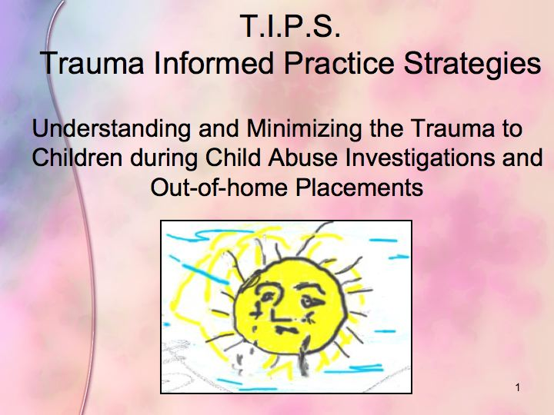

Script:
- Welcome to training on reducing the trauma druing investigation, removal, and out-of-home placement for children in child abuse cases.

- My background, experience and interest in this topic are as follows…

- I’m interested in knowing a little more about all of you here at today’s training.

Trainer's Note | - For groups of 10 or fewer, invite participants to introduce themselves by sharing their name and work context as it relates to the training topic  - For groups larger than 10 ask participants to raise their hands according to the following prompts.  - Those with less than 5 years of experience working with this topic  - 5 to 10 years experience  - 10 to 15 years experience  - 15 to 25 years experience  - Over 25 years experience

- There are gifts in having this immense experience in the room and gifts in having fresh hearts and minds with little experience in the room. I welcome all of you and look forward to your contributions in generating practical strategies that are informed by the research for reducing trauma to children during investigation, removal and out-of-home placement.

  - Before we begin, I want to give special recognition to those of you in the audience who may have experienced trauma in your own childhoods. Research tells us that abuse histories are overrepresented in the childhoods of those of us in the helping professions. For any of you, if the content of today's training at any time becomes difficult to listen to or experience, please feel free to excuse yourself from the training room.
- Today you will leave with new ways of doing your work that won’t add to your workload but rather enhance the way in which you do your work so that you can more intentionally attend to reducing trauma and retraumatization of children during investigation, removal and out-of-home placement.

- Let’s begin with a definition of trauma and share the experience of a child traumatized by the domestic violence she was exposed to in her own home.
Section 2 Gain Attention: Experiencing the Trauma of a Child
Time: 15 minutes
Materials: PowerPoint slides 2-5; Lisa 911 audio recording; Audio capabilities for playing the 911 audio download
Key Content:
- Defining trauma
- Gaining buy-in to the topic through the witness of a child’s trauma in a 911 call

Trainer's Note | While showing PowerPoint slide 2, deliver the content in points 1-3 in the script below.

PP 2
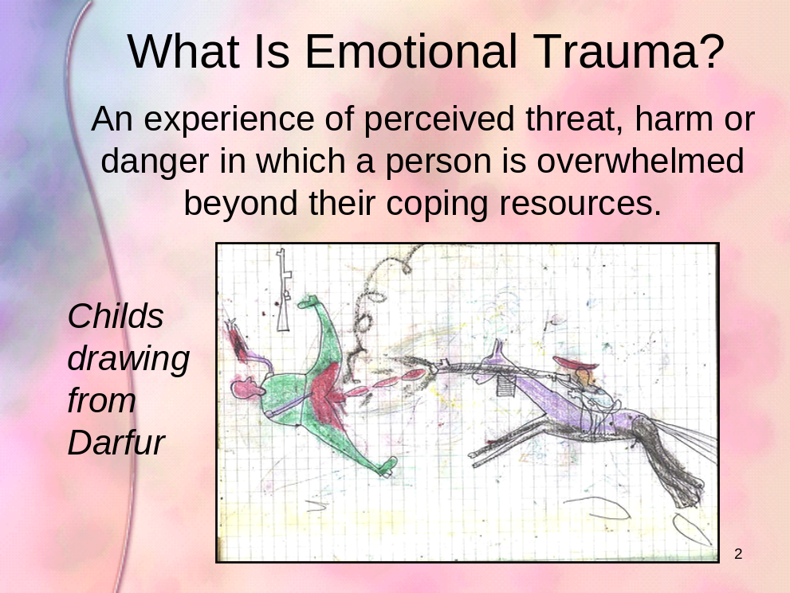

Script:
- Emotional trauma can be defined as an experience of perceived threat, harm or danger in which a person is overwhelmed beyond their coping resources.

- Traumatic events overwhelm a child’s capacity to cope and elicit feelings of terror, powerlessness, and out-of-control physiological arousal.

- Acute trauma is a single traumatic event that is limited in time, such as a natural disaster.

Trainer's Note | While showing PowerPoint slide 3, deliver the content in points 4-5 in the script below.

PP 3
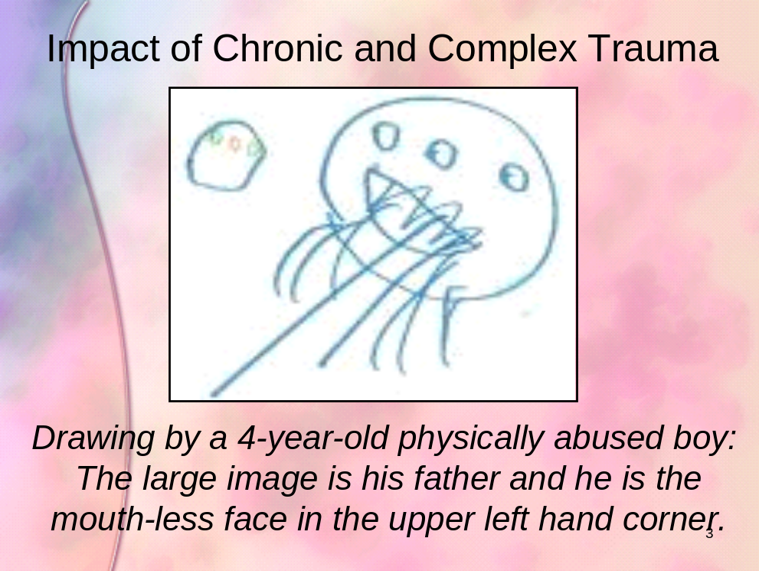

- Chronic trauma refers to the experience of multiple traumatic events such as ongoing domestic violence or physical abuse or neglect.

- Complex trauma involves multiple or prolonged traumatic events, is chronic, is usually caused by adults entrusted with the child’s care and begins in early childhood.

Trainer's Note | While showing PowerPoint slide 4, deliver the content in point 6 in the script below.

- How a child responds to trauma depends on a number of factors

PP 4
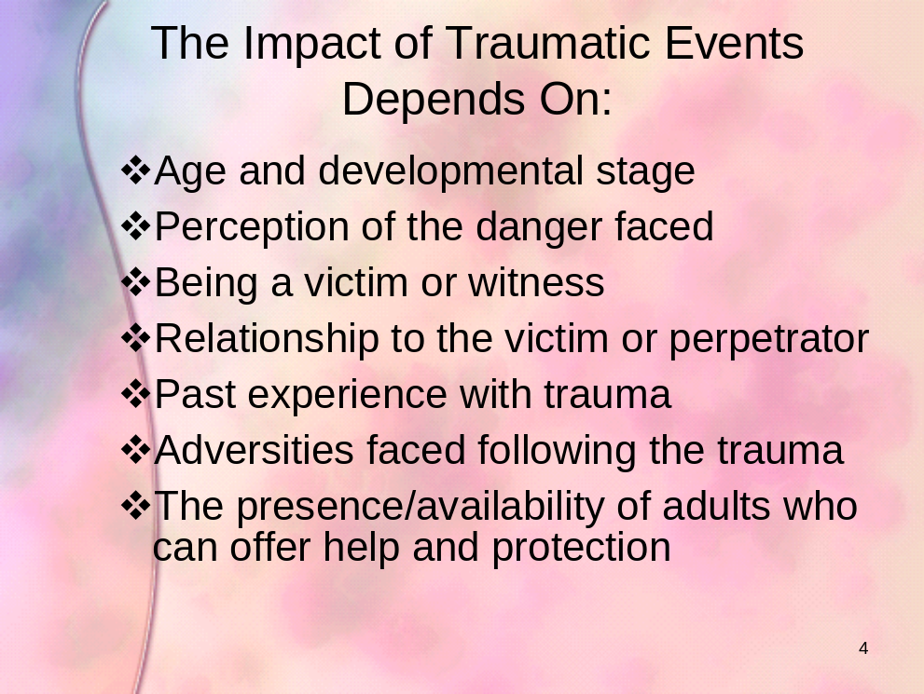

Trainer's Note | While showing Power Point slide 5, deliver the content in point 7 in the script below.

- Let’s listen to a five-minute 911 call of a child named Lisa experiencing the trauma of domestic violence between her parents. While you are listening, notice the following:

PP 5
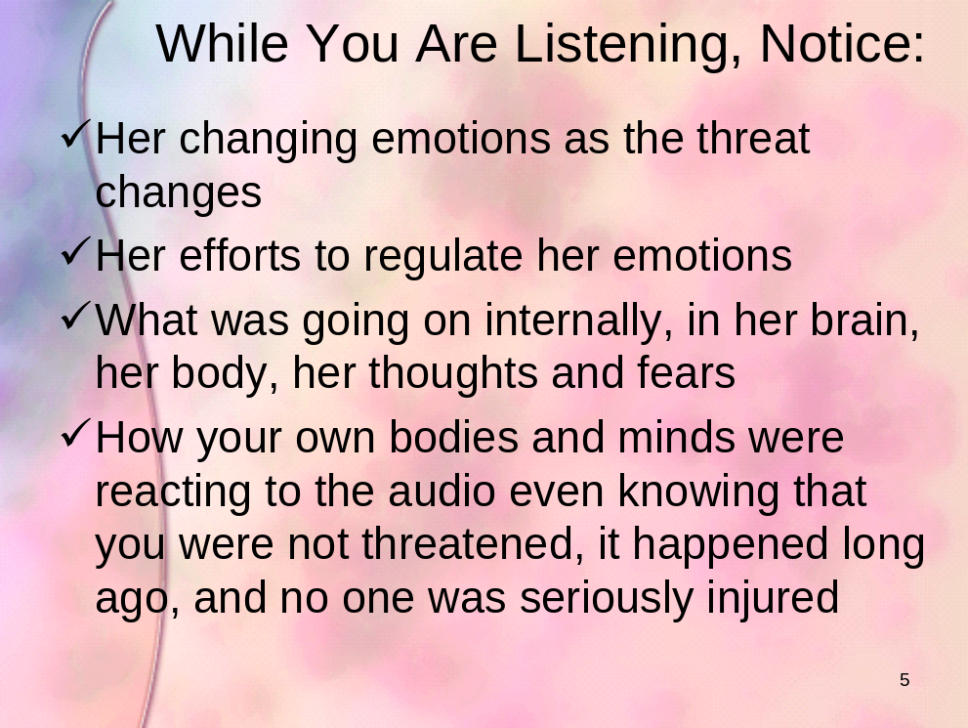

  Media | Play five-minute 911 call demonstrating the trauma experienced by a child in a domestic violence situation.

- Let’s debrief this by hearing what you think Lisa’s immediate needs are and what your responsibilities as first responders might be in responding to those needs.
Section 3 Stimulate Recall: What Children Need from First Responders
Time: 15 minutes
Materials: Power Point slide 6; Easel pad(s) with stand(s); Fine-tipped colored markers such as Sharpies™; Post-It™ Notes
Key Content:
- Identifying immediate needs of a child like Lisa
- Identifying what first responders can do to meet a child’s needs
- Affirming what you already do well in your work with traumatized children and building upon that foundation

Script:
- You are already doing many things well in your work as first responders at initial investigation, removal and placement. Using Lisa as a case example, think about what needs she has and what responsibilities you have towards her as a first responder and how you typically meet those needs.

- We will debrief Lisa’s 911 call with the following activity.

Flip Chart    Exercise | - Set up 1 easel pad with stand for every 25 participants.  - With 25 or fewer participants, lead the activity as a large group debrief according to the instructions below.  - With 25-100 participants, ask participants to distribute themselves evenly among the easel pads and stands and to follow the instructions below.  - Review instructions on PowerPoint slide 6.  - Provide an example of a need such as “Reassurance” and an example of a response to meet the need such as “Stay calm and speak gently.”

PP 6
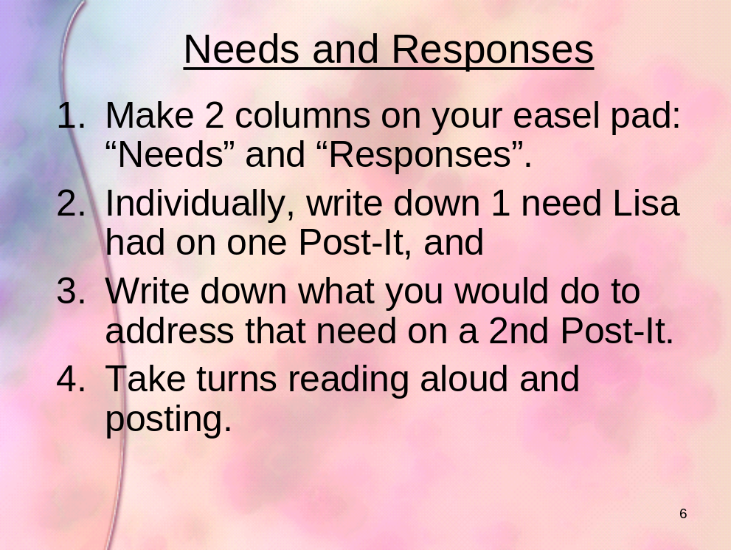

Script:

You have generated many responses that you would use to respond to the needs of a child like Lisa. Let’s build on that solid foundation by taking a closer look at the biology of trauma and how you can enhance your capacity to respond to in a way that will support resiliency in children.

Section 4 Share Training Outcome and Agenda: What You Will Do
Time: 5 minutes
Materials: PowerPoint slide 7
Key Content:
- What you will be able to do in your work as a result of today’s training
- What you will do in today’s workshop to help you meet the training outcome

Trainer's Note | While showing PowerPoint slide 7, deliver the content in point 1 in the script below.

Script:
- In the last activity we saw that you are already doing many things well in your work as first responders at investigation, removal and out-of-home placement. Today’s workshop will support you in enhancing and deepening your practice through work towards the following outcome:

PP 7
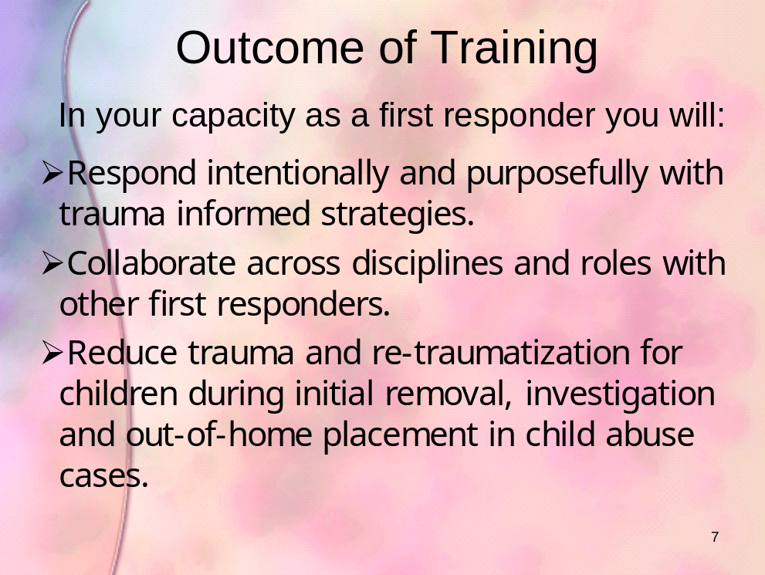
Section 5 New Content: The Biology of Trauma
Time: 30 minutes
Materials: Power Point slides 8 – 16; Handout
Key Content:

What trauma is

How it impacts the developing mind

Strategies first responders can use to support resiliency and healing in children

Trainer's Note | While showing PowerPoint slide 8, deliver the following script, Introduction to the Biology of Trauma.

PP 8
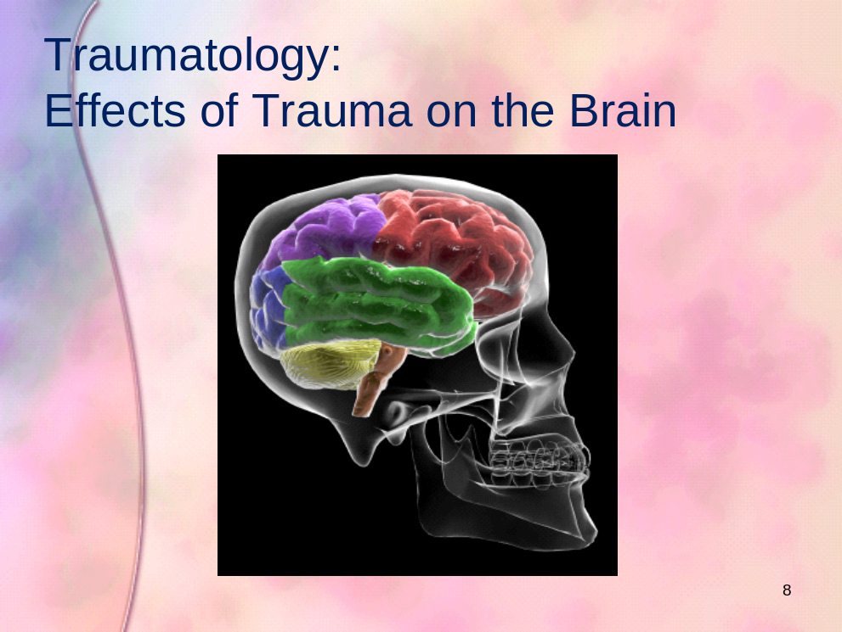

Script: Introduction to the Biology of Trauma
- Let’s begin with an overview of how life experiences in general influence brain maturation and mental health. Countless studies have been able to demonstrate that nature depends on nurture. That means personal interactions literally impact the biological structures of the brain and how we relate to others and ourselves. These interactions have the ability to either harm or heal brain maturation and mental health.

- In today’s workshop we will not only explore the biology of trauma on brain maturation and mental health, but we will work together to identify strategies that you can use during the initial removal, investigation and placement of these children to reduce and then positively contribute to healing the trauma associated with child abuse.

- Let’s begin by looking at the incredible resiliency of the brain and it’s ability to recover from trauma

Trainer's Note | While showing PowerPoint slide 9, deliver the following script, Brain Plasticity (Adaptability).

PP 9
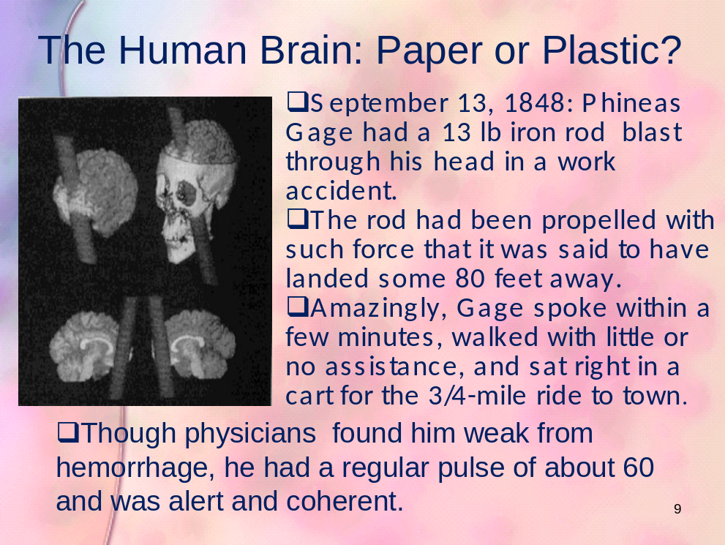

Script: Brain Plasticity (Adaptability)
- The human brain is considered to have high “plasticity”. This means that it can adapt and conform to the internal and external environment in ways that enable survival. For instance, the brain can not only withstand traumatic brain injury, but it can repair itself in ways that have both surprised and perplexed scientists for centuries.

- One common example used to illustrate brain plasticity is the experience of Phineas Gage. While working for the railroad, Phineas was in charge of using dynamite to clear land for tracks. Part of the process involved using a 13 pound iron rod to pound dynamite into deep holes that had been pre-drilled into mountain and rock. On September 13, 1848, Phineas had unknowingly used a rod dusted with gunpowder to pound dynamite securely into the rock. This resulted in a large explosion that thrust the iron rod through the side of his face and out of the top of his head. To the great surprise of everyone, he lived and was functional for several years following the accident. Of course, he was blind in the left eye, experienced difficulties with emotional regulation and planning, but this massive traumatic brain injury did not impede his ability to lead a relatively functional life until he died 12 years later from convulsions, presumably related to the injury. This informed neuroscience in ways that contributed to success in the development of neurosurgery.

Exercise | - Ask participants: What implications does Phineas’ experience have for children exposed to the trauma of child abuse?  2. Hear and affirm participant responses.

Script: Brain Plasticity (Adaptability)
- From Phineas’ example of brain resiliency we can conclude that no child is broken, regardless of past trauma or present behaviors. Some children might have greater challenges to overcome depending on the extent and duration of trauma experienced, but still, recovery is possible in varying degrees for all children given a safe, stable, forgiving, and nurturing environment. All children deserve optimism and hope from helping adults, and all helping adults deserve the warmth in their soul that optimism provides. Today we will explore strategies you can use in the context of your regular responsibilities during initial removal, investigation or placement that will contribute to healing trauma in children. We won’t be adding to your workload, but instead identifying ways in which you can do your work that will accomplish your goal while also contributing to healing in children.

- First, let’s take a closer look at the brain.

Exercise | While showing Power Point slide 10, conduct the following activity, Are You Left or Right Brain Dominant?

PP 10


Script: Are You Left or Right Brain Dominant?
- Take a look at the spinning lady. If you see her turning clockwise, raise your hand.

- If you see the spinning lady turning counter-clockwise, raise your hand.

- More than half of us will see her turning clockwise. The rest of you see her spinning counterclockwise. Some of you will be able to switch between clockwise and counter-clockwise. What do you think determines how you perceive her spinning?

- The direction in which you see her spinning is an indication of which side of your brain is dominant. Those of you who see her spinning clockwise are right-brain dominant. The right brain or right cerebral hemisphere is associated with nonverbal communication, intuitive feelings, creativity, and non-linear rationality. Those of you who see her spinning counter clockwise tend to be left-brain dominant. The left-brain, or left cerebral hemisphere, is responsible for logic, language, verbal speech, and understanding cause and effect. If you can see her spinning both ways, you are able to use both your left and right brain with comparative ease.

- Look again, but this time shift your gaze just above the image and use your peripheral vision. Can you see her turning the other way now? Raise your hand if you can see her spinning the opposite direction in which you initially saw her?

- As we saw in this simple demonstration, people view things differently.

Exercise | - Ask participants: How can this kind of difference in perception play out between children and helping adults during child abuse investigations and/or the removal and placement process?  - Hear and affirm participant responses.

- Because perception is different from person-to-person, and perception varies depending on developmental stage and is also greatly impacted by trauma, let’s take a look now at the biology of trauma and the impact on the developing mind of a child.

Trainer's Note | While showing Power Point slide 11, deliver the following script, Left and Right Brain Processes.

PP 11
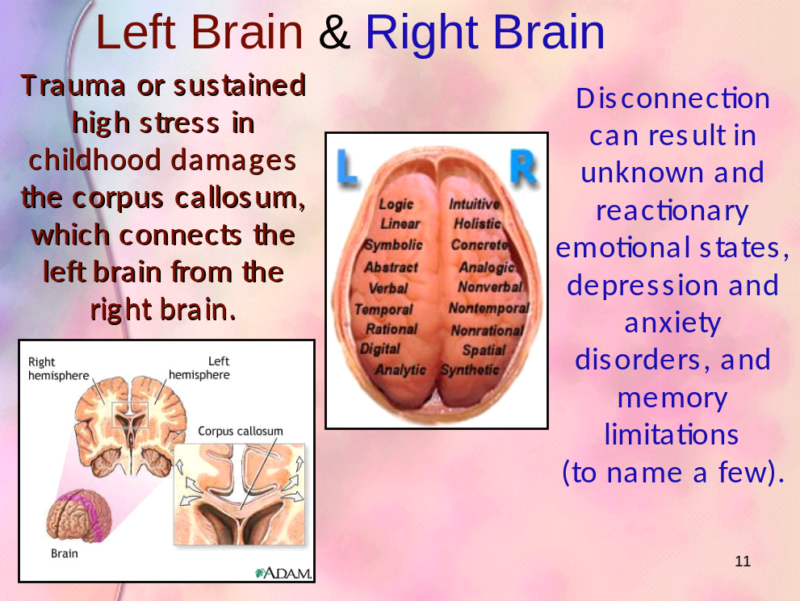

Script: Left and Right Brain Processes
- One of the greatest determining factors associated with resiliency of past trauma involves an individual’s ability to make sense of the experience. One of the reasons why psychotherapy is thought to assist individuals in healing from past trauma is, through verbalization, the left brain integrates with the right brain. This integration can happen for children when caring adults support them in creating a verbal narration or story about the traumatic event. For younger children, this integration can happen through play. Let’s see how this happens.

- The right brain (right cerebral hemisphere) processes nonverbal language and signals, enables self-soothing to take place, interprets facial expressions, and is in charge of autobiographical memory (to name very few of its functions). Autobiographical memory enables us to understand the story of our own life in relation to others and ourselves and is only accessible when the left brain is involved in the autobiographical processing. The right brain, which is the nonverbal part of the brain, also keeps traumatic experiences silent when it is prevented from communicating with the left brain.

- The left brain (left cerebral hemisphere) processes logic and language. This part of the brain looks for the understanding between right and wrong, striving to understand cause and effect. The left brain is dependent upon the right brain in order to form a narrative autobiography – the ability to make sense out of an experience – through verbal or written communication, which is critical in creating resiliency and the ability to rebound from adversity and trauma.

- In The Developing Mind, leading interpersonal neurobiology expert and psychiatrist Daniel Seigel, PhD., notes the importance of left and right brain integration in determining our ability to experience resiliency and to heal from trauma. He suggests that, “It isn’t just what happened to you that determines your future – it’s how you’ve come to make sense of your life that matters most.” This is where caring first responders can really make a difference in the life and healing of a child!

- Severe and prolonged emotional trauma can damage the part of the brain that connects the left brain to the right. In effect, this structure enables the left brain to communicate with the right brain. This structure is called the corpus callosum (kore-pus kuh-low-some). Recall from earlier that the ability of the left brain to “talk” with the right brain determines whether a person will be able to make sense out of the trauma and recover. As a first responding professional or foster parent, you can contribute to supporting this process by explaining to children in developmentally appropriate language what is happening and what will happen next. Furthermore, by having a child verbally communicate their understanding of what is happening and what will happen next, you will not only be able to hear if you communicated accurately, but you will also be helping them verbalize their understanding, which will assist with left and right brain integration. Other ways in which you can help a child form coherent narratives are to inform the child of what is happening, that people are here to help, that they are safe, and that their parent(s)/siblings are safe. Because it is difficult to know the various logical and illogical ways a child might blame themselves for their circumstance, one way to help a child to better make sense of their experience is to let them know they are not at fault and then open up a two-sided conversation with them about why they are not to blame. As a follow up to providing a coherent narrative for the child, you can also advocate for mental health counseling that will support the child in the brain integration process around the traumatic event.

- In addition to providing a simple narrative and advocacy for mental health counseling, helping adults can also use the science of social attachments to positively contribute to a traumatized child’s resiliency. Let’s see now how that works.

Trainer's Note | While showing Power Point slide 12, deliver the following script, How Do Neurons Respond to Trauma?

PP 12
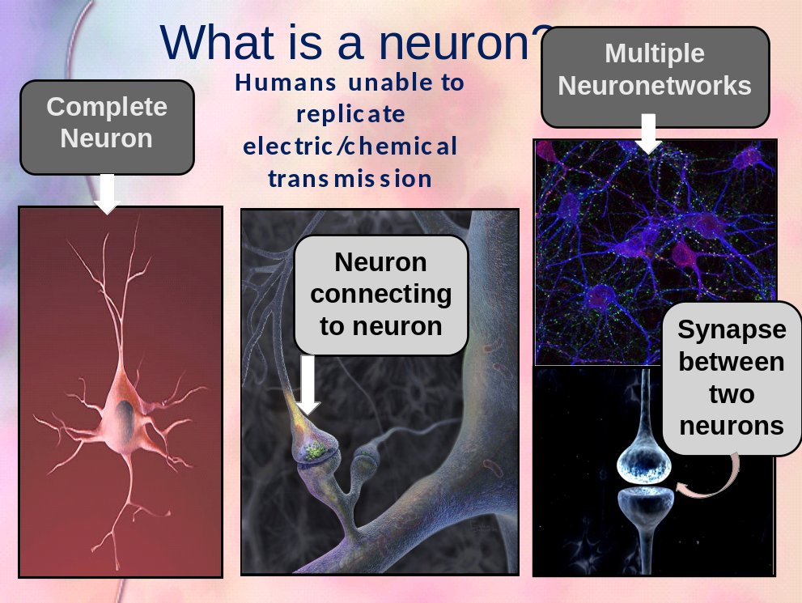

Script: How Do Neurons Respond to Trauma?
- When an individual experiences trauma, massive floods of various different brain chemicals (neurotransmitters and stress hormones) are released throughout many structures in the brain. When this happens, the “fight, flight, or freeze” alarm sounds off, preparing the individual for survival by letting the rest of the brain and body know that danger is impending. The brain structure responsible for sounding this alarm (limbic system) tells us when to run and when to stay and fight, providing the necessary chemicals to optimize chances for survival. Because the limbic system is mostly unconscious, oftentimes traumatic triggers prevent a trauma survivor from knowing why they feel what they feel. In other words, sometimes they are unable to identify what they are feeling. For example, some traumatized children respond to kindness from adult helpers with anger, fear, and/or aggression. When a trauma survivor is flooded with stress hormones (result of a traumatic trigger or reminder), they may exhibit behavioral reactions that many adults might view as rebellious, combative, hyper, out-of-control, uncaring, over-emotional, and unwilling to pay attention or remember things. Oftentimes child trauma survivors won’t be aware of why they are behaving in any particular way due to the unconscious nature of trauma (located in the unconscious limbic system). The reality for these children however, is that they are literally fighting for their lives, whether there is an actual threat or not, and whether they realize it or not.

- Therefore, a trauma survivor cannot be told how to think, behave, or feel when traumatic episodes take place any more than a person with a broken leg can just “shake it off” and walk without a limp. Child trauma survivors experience biological and chemical responses that last for prolonged periods of time. Cell recovery takes the right kind of intervention (cast for a broken leg with crutches) and time for cells to form strength (how long does it take for a broken bone to heal?). Biology takes precedence, therefore an emotional and physically safe and consistent environment are imperative. We cannot determine what a traumatized child should think or feel anymore than we can direct a person with a broken leg to simply walk like everyone else. It is crucial to keep this in mind when working with anyone suspected of experiencing past trauma or the trauma that results from being forced to leave one’s home living environment. When you recognize the biological responses to trauma in a child’s behavior (hyperactivity, isolation, aggression, anxiety, fear, or people pleasing), it is important to respond to the behavior in a manner that can reduce traumatic symptoms. This will foster resiliency within the traumatized child.

- The developmental age of an individual influences the extent to which the damage caused by trauma, and the accompanying brain bath of stress hormones, can be repaired. Brain cells (neurons) live by the principle of “use it or lose it”. If neural connections are not formed early on in the development of the brain (from birth to early childhood), specific neurons in specific parts of the brain die.

- Let’s look now at exactly what happens biologically when trauma is experienced and how a nurturing and stable environment can heal behavioral challenges associated with child trauma survivors.

Trainer's Note | While showing Power Point slide 13, deliver the following content, Cells That Fire Together, Wire Together.

PP 13
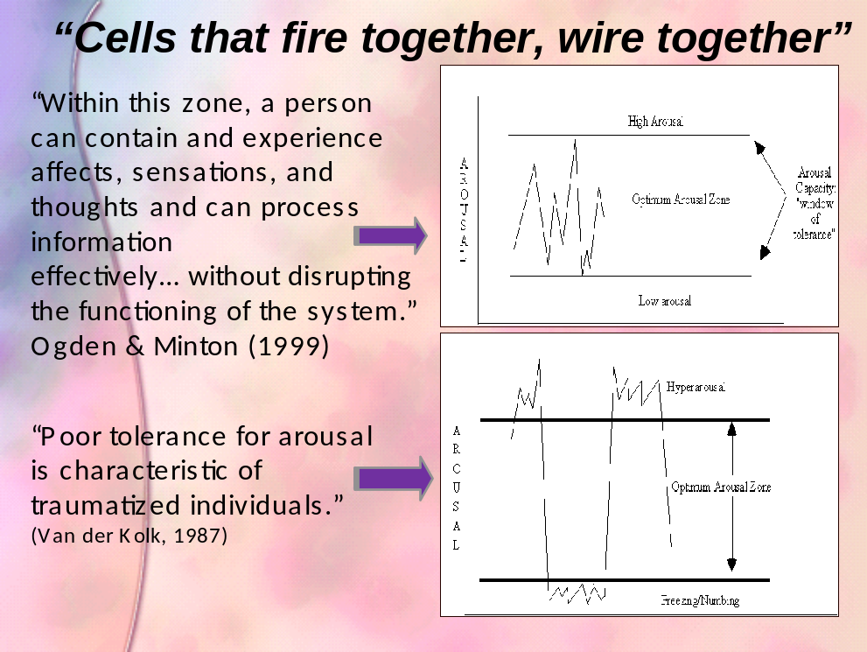

Script: Cells That Fire Together, Wire Together
- An individual experiencing standard levels of brain cell (neuron) activity fluctuates between peaks and valleys, which assists them with active engagement with internal (psychological) and external (social and natural) environments, and performance in work, school, and recreation. This level of activity, also called “arousal”, takes place in what is called the “Optimum Arousal Zone”.

- When an individual experiences trauma, brain activity rises to extremely high levels through the release of chemicals called neurotransmitters and stress hormones. For children who live with consistent high-level stress (not necessarily trauma), research has shown a decrease in development of brain structures that deal with learning and memory. This is one reason why surviving trauma is associated with learning disabilities.

- It is because of this high and low arousal instability that traumatized children sometimes perceive threats where there are none and respond accordingly. Children who experience fluctuations between hyperarousal and numbing often exhibit behaviors that perplex adults. Sometimes children will express high levels of anger or sorrow after a caring adult expresses kindness.

- The biological explanation for this is that emotional regulation is nearly impossible for a child whose neurons fire too rapidly or too slowly. Recent research has demonstrated that the vast majority of successful suicides in America can be correlated to childhood trauma and abuse. Suicide is a behavioral response to biological dysregulation and irregular states of over- and under-activity.

- When the brain of a child trauma survivor is unable to regulate high and low levels of activity, the child is often as confused about their emotions and behavior as helping adults are. It is not uncommon for children in this state to be misdiagnosed with ADHD, oppositional defiance, or even bipolar disorder. Medications prescribed to trauma survivors for these diagnoses can make symptoms worse, leading to medication trauma (side effects that make a person believe themselves crazy) or to the development of suicidal ideation). This can result in the child experiencing social stigma and internal feelings of inadequacy, in addition to the initial trauma.

- As a helping adult attending to a child at initial removal, investigation or placement in child abuse cases, it is important to understand that any extreme reaction from a child could be related to their biological inability to interpret some situations in moderate ways. It is only when these elevated and low levels of brain arousal reach stabilization in the Optimum Arousal Zone that a child will be able to experience emotional stability in everyday events and perceptions. And this can only happen through the consistency of nurturing and emotionally safe environments. Even though you may have limited contact with children at particular points in the process of initial removal, investigation or placement, you can contribute to the emotional safety of traumatized children. You can assist in reducing trauma experienced by an abuse investigation or removal from home by adding biological strategies to your helping toolkit. These strategies involve providing comforting sensory experiences that reduce traumatic responses and foster emotional safety. Let’s see how that works.

Trainer's Note | While showing Power Point slide 14, deliver the following content, Self-Regulation and Healing.

PP 14
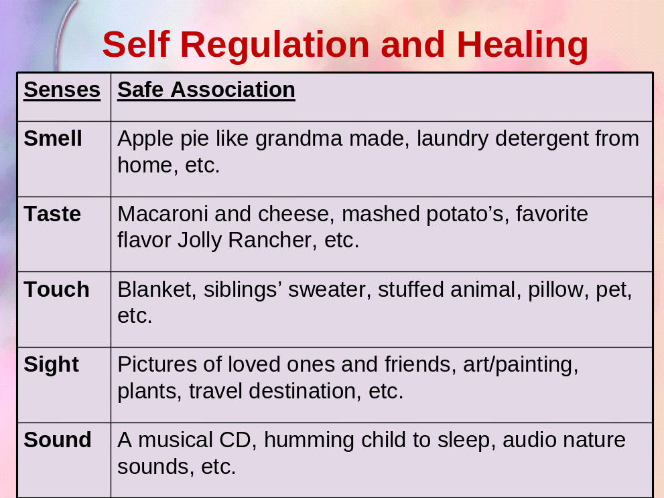

Script: Self-Regulation and Healing
- The human brain stores unconscious traumatic memory that is awakened when a smell, noise, taste, sight, or feeling reminds a survivor of the traumatic event. Because this memory is typically unconscious, child survivors often respond to such sensory ‘reminders’ in ways that confuse helping adults. They might become aggressive for no apparent reason, hyperactive, depressed, unable to pay attention to others, or even clingy to adults they view as safe. While this behavior can be confusing for adults, it is even more confusing for the child, confusion which then fuels the unstable behavior. Children (and sometimes even their adult helpers) will often blame themselves or others for this change in mood, when the real culprit is the traumatic memory that was triggered by an unknown sensory experience.

- One of the most common triggers of memory in all human beings is the sense of smell. This is due to the close proximity of the smell-processing center to the emotion-processing center in the brain. As a result, smell is the first sense to activate brain response in any situation. In cases of trauma, a smell can be the safety mechanism triggered to tell the amygdala of impending danger. If a child smells the same laundry detergent in a safe setting (a foster home) that he smelled in a setting associated with chaos and upset, the smell of the detergent in the safe, foster home could trigger a trauma response causing aggressive, hyperactive or depressed behavior in the child; all without the child’s conscious awareness and certainly to the puzzlement of the caring, kind foster parent. This is why it is critical to make sure the sensory comforts provided are, in fact, comforting.

- If the brain can respond negatively to smell, can the opposite be true? Yes.

- When working with traumatized individuals, it is very important to consider the role smell plays in traumatic memory as well as in healing. One thing helping adults can do is find out what smells children identify with safety and positive memories. Caring adults can use these positive smell memories (homemade apple pie from grandma, a particular soap that a comforting uncle used to clean a wound, freshly cut grass before a soccer game where people cheered for him, etc.) to provide sensory comfort to stressed or traumatized children.

- If this is true for the sense of smell, is it true for the other senses as well? Yes.

- This is true for all of our senses. Sometimes the most beneficial thing a helping adult can do to reassure a child is not spoken with words at all, but with reminders of external cues the child can assign their own meaning of safety to. Children can feel safe with a particular blanket or stuffed animal (touch), a musical CD or adult humming them to sleep (sound), pictures of loved ones (sight), or macaroni and cheese (taste).

  Handout  Exercise | - Distribute handout titled Safe Sensory Tools  - Ask participants: What sensory comforts can you ask about and then provide as you interact with the child as a first responder?  - Hear and affirm participant responses.

- Children removed from their homes are lonely children. They don’t know the strangers helping them and, in a very real sense, are alone; everything familiar to them is left behind. There are very few words from strangers that can calm traumatic emotions. However, if children are able to have familiar sensory experiences that are associated with safety, their brains can change biological responses that can calm fears down. Over time, these safe sensory tools enable child trauma survivors to emotionally self-regulate. When this happens, they are better able to experience resiliency.

Trainer's Note | While showing Power Point slide 15, deliver the following content, Social Attachments Determine Brain Biology.

PP 15
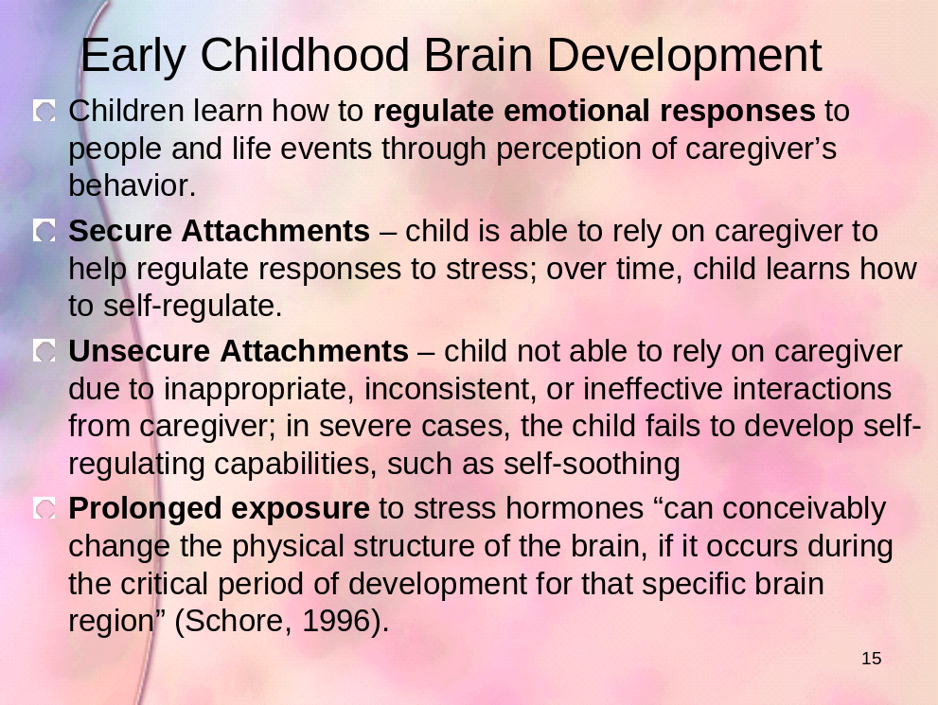

Script: Social Attachments Determine Brain Biology
- Some of the greatest influences on early childhood brain development are the social interactions young children experience. Children are introduced to the world and themselves through the input of their social attachments. Healthy brain development requires secure attachment(s) in order for healthy neural connections to take place, which include optimal learning abilities and emotional regulation to name a couple. When a child is subjected to abuse or neglect, neural connections involving shame and alienation form, continuing to strengthen both during and after a traumatic experience. While these neural connections are forming, other developmental connections have difficulty forming strong connections. This is due to the brain’s biological response to environmental threats to safety. A healthy brain is able to fully develop a brain structure that deals with learning and memory (hippocampus), while a brain exposed to emotional trauma has been shown to experience a decrease in volume of the hippocampus – as demonstrated by brain imaging studies in trauma survivors. This is one fundamental reason why children who experience Posttraumatic Stress are at an increased risk to experience learning challenges and difficulties regulating emotions.

- Once the threat to safety has ended, the process of forming new neuronetworks occurs slowly in a safe and nurturing environment. However, if the threat to safety ends and the child remains in an emotionally neglectful or abusive environment, unhealthy neuronetworks already formed, such as shame or self-blame, continue to strengthen. This is because “neurons that fire together wire together”. The more neurons (brain cells) are used, the stronger their connections become (neuronetworks). The way to support children in forming and strengthening healthy neuronetworks is through positive interactions and a safe environment. As a helping adult, you can support this important process by advocating for close contact with friends and family as soon as possible and when safe, minimizing the number of placements the child experiences, and advocating for the utilization of qualified mental health professionals to assist children in navigating the adaptation and recovery processes associated with trauma. While these things are critical for healing, it is important to remember that because the process of forming new neuronetworks is slow, it can take awhile to influence the rate at which a child heals from trauma. Your advocacy must be combined with patience and refusal to give up on any child.

Trainer's Note | While showing Power Point slide 16, deliver the following content, Nature Needs Nurture.

PP 16
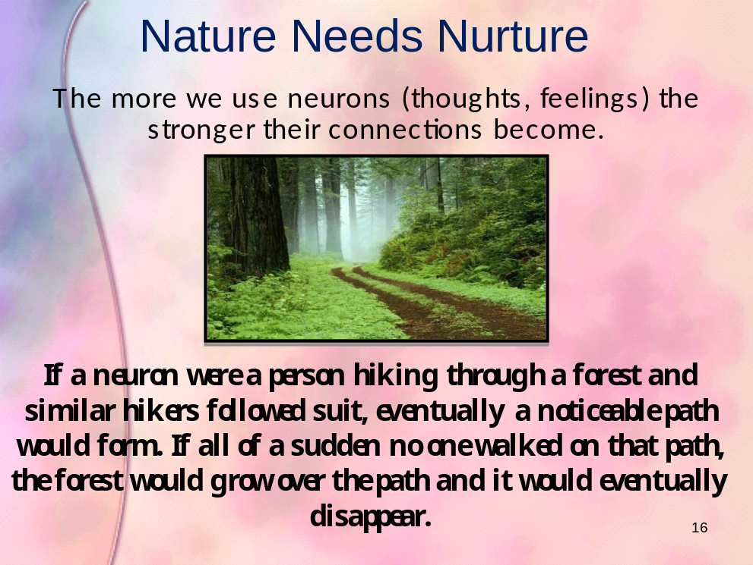

Script: Nature Needs Nurture
- Remember… “Neurons that fire together wire together”. All human interactions shape and mold the structure of the brain. A healthy attachment formation provides the stability for the brain to learn and grow. This means the social environment literally causes biological processes to take place, including the development of neuronetworks. Frequency of social interactions determines the strength or weakness of neuronetwork formation. One way to understand how neural connections are formed, strengthened and weakened is to compare those connections to a path in a forest. Many hiking paths have posted signs asking hikers not to stray from the path in order to keep the surrounding forest intact. If hikers (neurons) stay on the trail (network of neurons), the trail eventually becomes wider or distinct (producing stronger neuronetworks) that are easier to see, and distinguishable as the path to take. However, if hikers (neurons) stray from the path to the surrounding forest (new social/environmental experiences), new paths begin to form. Eventually these new paths take on the size and shape of the original main path. With the main trail neglected, eventually forest grows over the path and it returns to looking like the rest of the forest (diminished neural connections or cell death).

- This metaphor can help us understand why the healing process of a traumatized individual can take different amounts of time depending on severity and extent of the abuse or neglect that took place. New neural connections being formed take time to build. When you think about how often a hiker would have to stray from the path before a new path begins to take shape you can begin to appreciate how long it takes the brain to recover from trauma.

- The good news for caring first responders is that even brief interactions have demonstrated the very real capacity to make a profound difference in a child’s life. Testimonials from child trauma survivors often involve stories about how one brief encounter with a caring adult provided them with the hope and strength to survive adversity. Your first response interactions have the very real capacity to act like a trailblazer in the brain of a child, beginning to lay down a path towards resiliency, recovery and positive development.

Trainer's Note | - This is a good time to take a 15-minute break.  - Ask your volunteer for the demonstration to return a few minutes early from the break to prepare for assisting you.
Section 6 New Content: The Impact of Trauma on Functioning
Time: 10 minutes
Materials: Handout: The Impact of Trauma on Child Development and Functioning
Key Content:
- The impact of trauma on child development and functioning

Script: The Impact of Trauma
- Before the break, you learned about the biology of trauma and the impact on the developing mind.

Handout | - Distribute the handout The Impact of Trauma on Child Development and Functioning.  - Introduce the handout with the script below then allow participants to take a few minutes to review each category of functioning.

- Here is a handout that summarizes the impact of trauma on child development and functioning. As you review this handout, think about the children with whom you work. There are many things caring first responders can do to provide structure for children as a way to support the areas of functioning that are impacted by trauma. For example, you can support emotional and behavioral regulation by the things you do and say and the way you are with children. To get an idea of concrete things you can do, let’s watch and listen to Katie’s story. Katie is a foster child who experienced multiple removals. In these clips she describes the unhelpful things first responding adults did and offers suggestions for helpful things we can do to provide structure and support to children challenged in these areas.

Section 7 Guided Practice: The Impact of Helpful First Responders
Time: 20 minutes
Materials: DVD Katie’s Stories of Removal; DVD player and TV or Laptop and projector; PowerPoint slides 17-18
Key Content:
- The positive and negative behaviors of first responders are shared through the experiences of a foster child.
- Participants brainstorm strategies within their work context to provide support in areas of trauma-impacted child functioning.

Script:
- Let’s watch the following clips in which Katie talks about her experiences being removed and placed in care and how the first responders had the power and ability to help or further traumatize her.
NOTE: Video clips are embedded in Power Point Slide #17

Media | Show 2 clips for a total of 10 minutes of Katie telling about her experience with first responders. The clips are as follows:  - As a 5 year old, police draw guns as she gets off the school bus and heads toward her house; she is “kidnapped” by the caseworker.  - What first responders could have done differently to help her?

Trainer's Note | While showing PowerPoint slide 18, deliver the following content, Variability in Response to Trauma.

PP 18
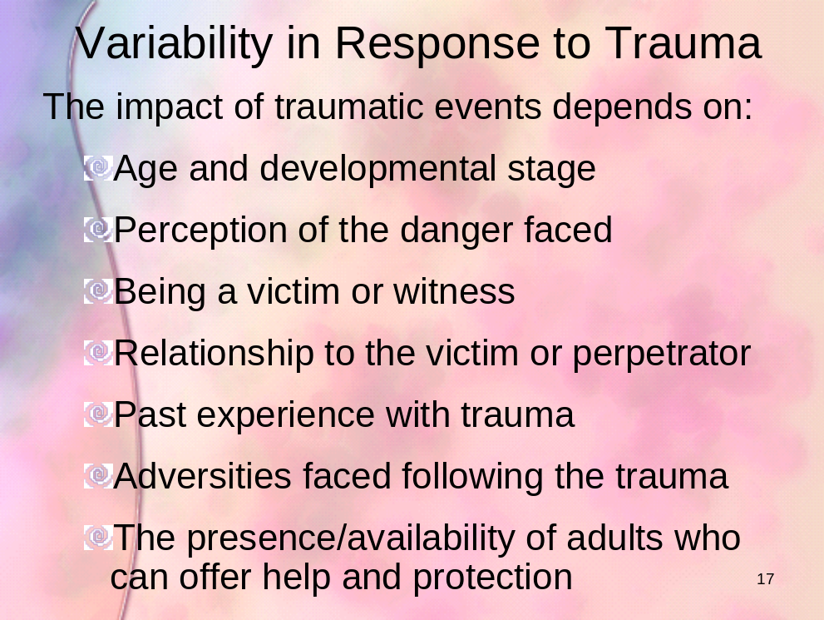

- A child’s response to trauma is determined by several factors. The only two you can impact are the last two bulleted items.

- Using the handout you received on child functioning and your impression watching Katie’s story, let’s do a short activity to generate some ideas for how you might contribute to reducing the trauma in your role as a first responder.

Exercise | - Review the instructions for Pair and Share Activity on PowerPoint slide 19 below.  - Participants only have about 5 minutes for brainstorming.

PP 19
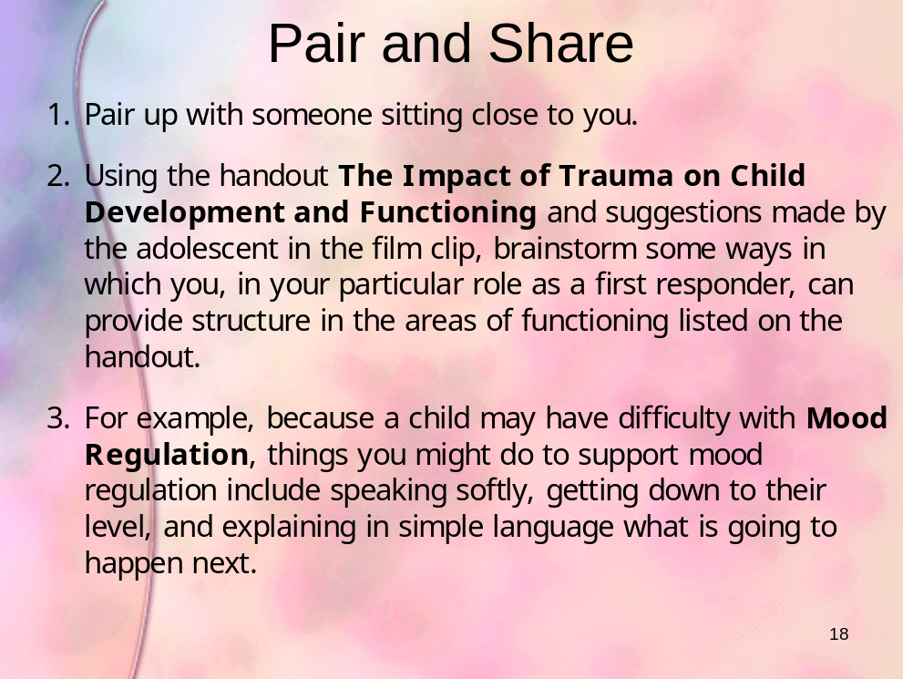

- Now that you’ve had an opportunity to begin thinking in terms of concrete strategies for reducing trauma, let’s turn our attention to our final activity, one in which you will work with a team to generate multiple concrete strategies for reducing trauma and retraumatization during investigation, removal and out-of-home placement.
Section 8 Elicit Performance: Trauma Informed Practice Strategies
Time: 45 minutes with a break embedded in work time
Materials: Team A Study Packets; Team B Study Packets; Team C Study Packets; PowerPoint slides 20-21
Key Content:
- Trauma Informed Practice Strategies (T.I.P.S) are applied in study teams with scenarios involving children at different developmental stages and different contexts. On-the-scene strategies for first responders will be generated that align with the research-based content of the training.
- These T.I.P.S are shared with others back in home teams.

Script:
- Now you will have an opportunity to apply everything you’ve learned today to your real-life context. We will do an application activity that will allow you to generate some practical strategies that you can use the very next time you are called upon as a first responder. Let’s take a look at the instructions for this activity.

Exercise  Trainer's Note | - Review the instructions (one at a time, allowing participants to complete each step) for Jigsaw Activity on PowerPoint slides 20-21 below.  - If you have a very large group, you may need to help participants break off into several groups within their letter designation. For example, if you have 30 A’s, 30 B’s and 30 C’s, you will need to guide them in breaking up into teams of 6, so that you end up with 5 A teams, 5 B teams and 5 C teams. No matter how many of each letter team you have, each person will return to his or her original home team to present.

PP 20
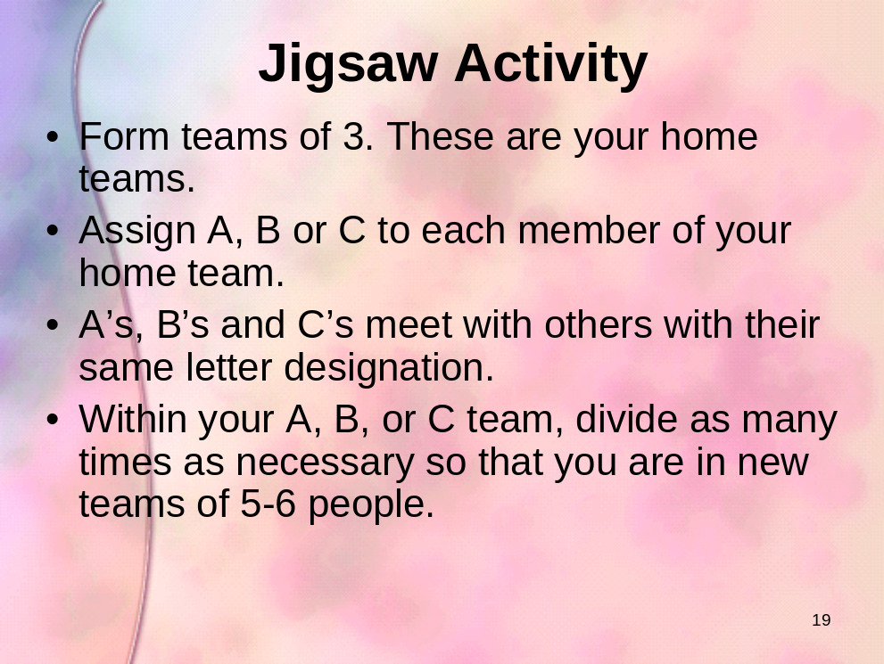

PP 21
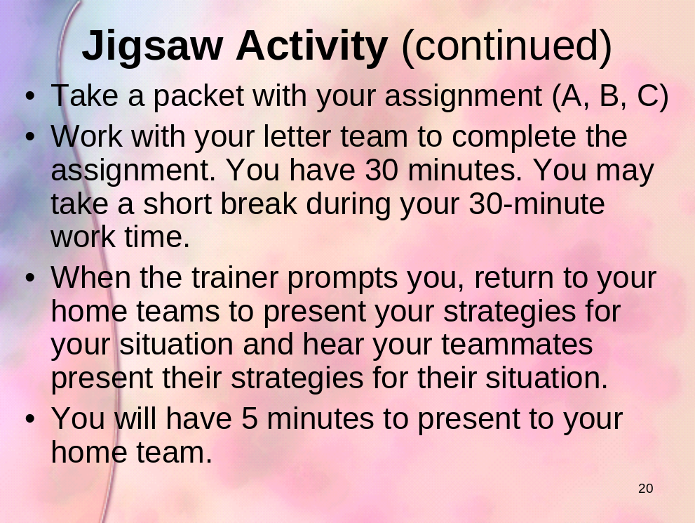

Trainer's Note | - Monitor time for participants. Call out two-minute warnings for both the study and presentation segments.  - Participants will have 25-30 minutes to work in their study (letter teams) including taking a brief break if desired, and then 15 minutes (5 minutes per person) in their original home teams to present.  - Call the entire large group back together for the last 10 minutes for closure.

Section 9 Closure: Bringing closure to the training
Time: 11 minutes
Materials: PowerPoint slide 22; handout: Biology of Trauma; handout: Special Considerations; handout: Helping Traumatized Children
Key Content:
- Final Q and A
- Appreciating the audience
- Saying goodbye

Trainer's Note | While showing PowerPoint slide 21, deliver the script below.

PP 22
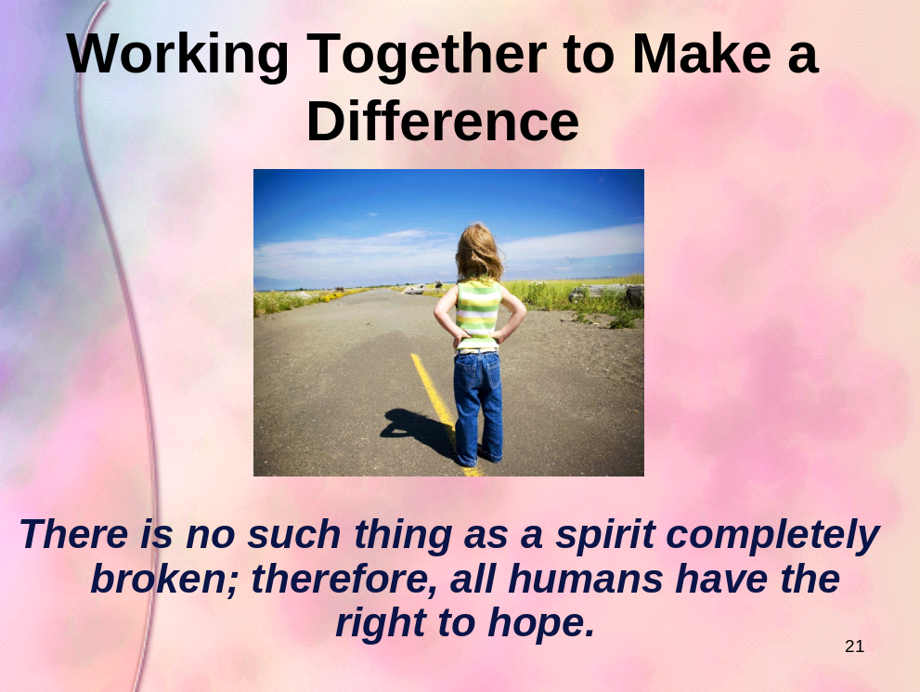

Script:
- As we wrap up today, are there any final questions, reflections or comments? We have about 15 minutes and can hear from a few people.

- There are some additional handouts for you that you can pick up on your way out. One is The Biology of Trauma, the second is Helping Traumatized Children and the third is Special Considerations. You can take these home as additional resources.

Handout | Make the following handouts available as participants leave the training: The Biology of Trauma, Helping Traumatized Children, and Special Considerations.

- I want to thank all of you for being here today and participating. I hope we have added to your toolbox of strategies as first responders at investigation, removal, and out-of-home placement in cases of child abuse. I hope we have encouraged you in the good work you are already doing and given you additional hope that every thing you do to contribute to safety, nurture, support, and protection for children is not wasted, because the human brain has enormous capacity for healing when good people do good things to take care of children.

- Thank you for coming and participating today.

Trainer's Note | Optional Activity for Child Welfare Caseworkers.  If you have an additional hour and a half and you are training child welfare caseworkers, you may choose to deliver the supplemental activity in the attached document on connecting policy to practice.

